HARVEST ASSIST app:
Pöttinger optimises forage harvesting
Pöttinger, the grassland specialist, always focuses on achieving the best working results and optimising processes when developing its machines and digital solutions. HARVEST ASSIST is a new, innovative app that helps to simplify and optimise logistics while harvesting forage.

The innovation
HARVEST ASSIST optimises forage harvesting by taking into account harvesting volumes, the distance between the field and the clamp, and optimising compaction performance in the clamp, to achieve the best quality forage. In addition, the app enables real-time communication using existing hardware. Available for iOS and Android, every member of the harvest convoy can install the app on their smartphone for free. This provides an intuitive overview for straightforward control of all the grassland harvesting machines.
The app makes it easy to add fields and assign them to each of the machines. There is a very clear overview of the fields to be harvested and also their status, e.g. whether they have already been raked and the crop collected.
The algorithm that calculates the optimum harvest sequence is especially innovative. The harvest volumes, the distance between each field and the clamp and the compaction performance in the clamp are superimposed on the display. This provides the tractor drivers with information on the optimised harvesting sequence so that they deliver crop to the clamp at regular intervals and avoid delivery peaks. Thanks to the intuitive display of the individual fields in the app, it is also easy for people who are not familiar with the farm to find each field and drive back to the clamp quickly using the integrated navigation system.

The features at a glance
In the app, the machinery portfolio consists of loader wagons, rakes, mowers, tedders, mergers and round balers. Everyone involved in each stage of the process gets an overview of the work progress in the field. The current status can be displayed for each field, showing whether it is being mowed, tedded, raked or collected. As soon as each stage is finished, the tractor driver can change the field status. This provides a structured view of which fields are ready for the next stage. These are then indicated to the driver with the next machine as soon as the field status has been changed.
In the live location view, each member of the harvest convoy is shown on an intuitive map along with the relevant machine and process. All locations are transmitted in real time, which greatly simplifies communication.
HARVEST ASSIST not only optimises forage harvesting but also compaction performance in the clamp. The compaction vehicle at the clamp has time to neatly distribute and compact each load of crop one by one.

The app is available in English, German, French, Polish and Czech.

Photo preview:
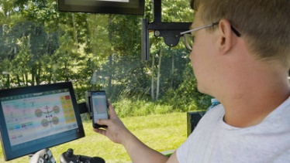 | 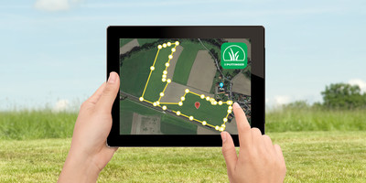
HARVEST ASSIST for optimising forage harvesting | Simply add and edit fields
https://www.poettinger.at/de_at/newsroom/pressebild/76967 | https://www.poettinger.at/de_at/newsroom/pressebild/49723

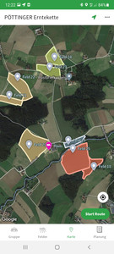 | 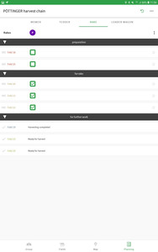
Display the process status of each field | Use HARVEST ASSIST to plan and track progress
https://www.poettinger.at/de_at/newsroom/pressebild/90826 | https://www.poettinger.at/de_at/newsroom/pressebild/90820

More printer-optimised photos:
www.poettinger.at/downloadcenter

